Report Extraction

by Aliaksandr Labayeu

There are 2 steps of loading fact table:

1. 2nd cleaning layer (bl_cl2)
2. Export to DWH (bl_cl2 -> dwh)

## Preparing data to load in fact:

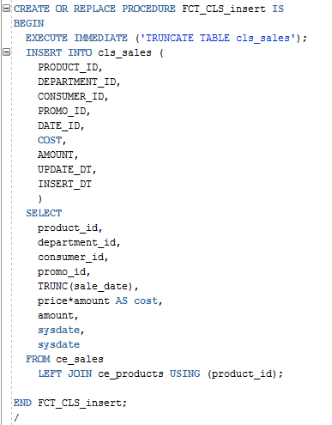

Result:

1st execution of procedure and SELECT + COUNT:

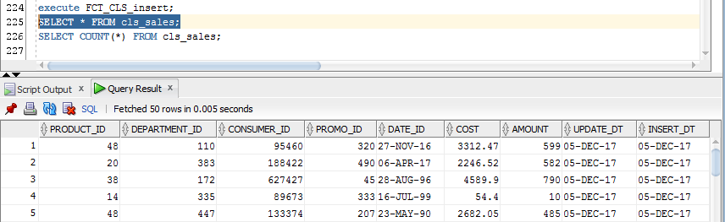

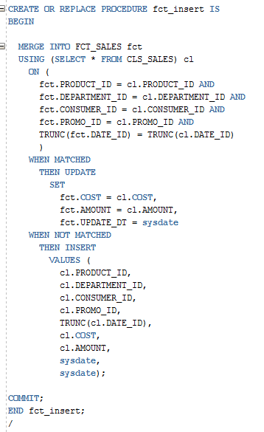

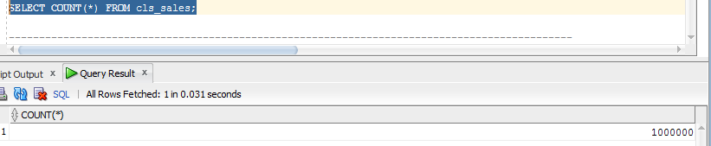

2nd execution

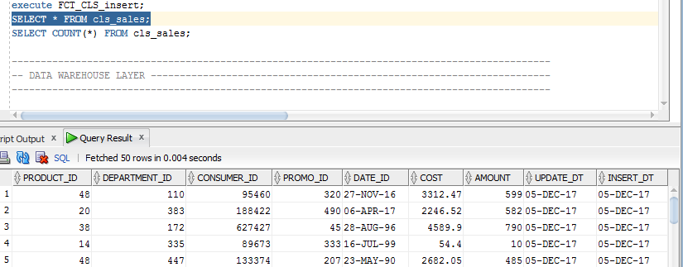

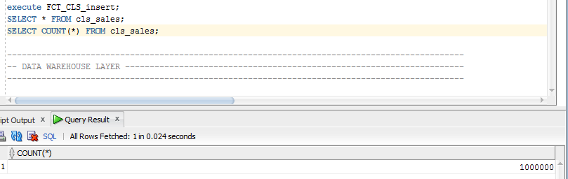

Of course we get same results because of the TRUNCATE statement that is used in procedure.

## Export to DWH

This operation is made with the help of MERGE statement:

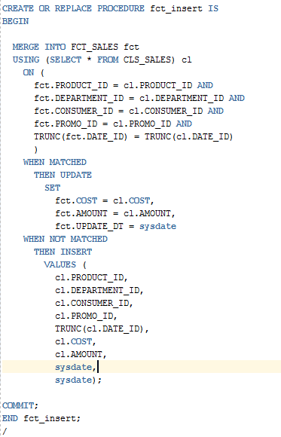

DWH Fact table 1st execution:

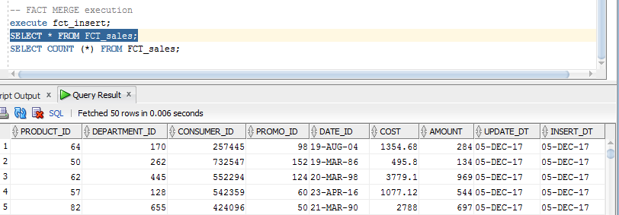

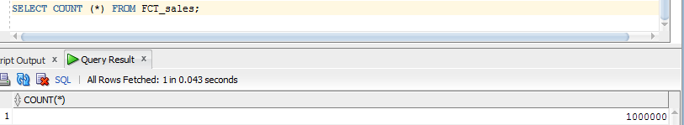

DWH Fact table 2nd execution

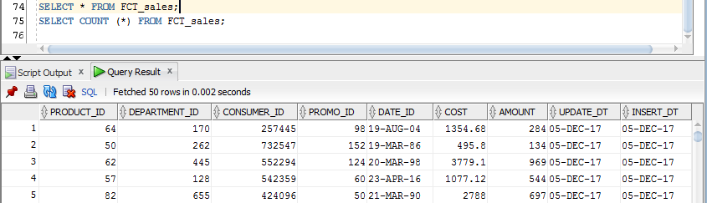

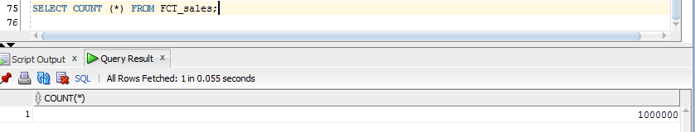

Results shows us that that there is no new records inserted in table because of the merge statement and TRUNC () of the data in tables DIM_DATE & FCT_SALES.

The final job is to wrap it in package:

